**Lab 3**

**Write C programs for the following:**

1. Read a person’s age and determine whether he/she is eligible to vote.
2. Read a number and test whether the number entered is positive or negative.
3. Read a number and find whether the given number is even or odd.
4. Given a character as input, check if it is a vowel. Print YES if it is so, otherwise NO.
5. Write a program to enter any character. If the entered character is in lower case, then convert it into upper case and if it is a upper case character then convert it into lower case.

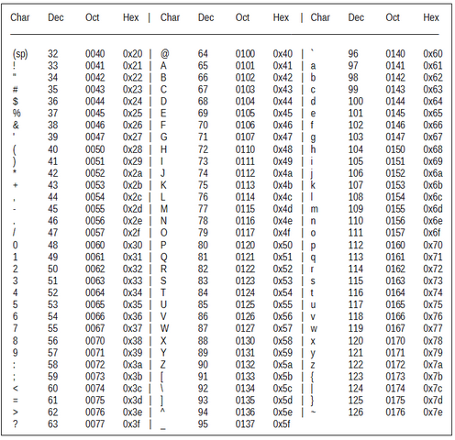

1. Accept two numbers from the user and find out the largest (using if-else)
2. Read a number and test whether a number entered is positive or negative or equal to zero.
3. A company decides to give bonus to all its employees on NewYear. A 5% bonus on salary is given to the male employees and 10% bonus on salary to the female employees. Write a program to enter the salary and gender of the employees. If the salary of the employee is less than Rs 10,000 then the employee gets an extra 2% bonus on the salary. Calculate the bonus that has to be given to the employee and display the salary that the employee will get.
4. Read an amount of seconds from the user and outputs the equivalent amount of minutes and the equivalent number of hours.

Sample Input: 3723

Sample Output: 1 Hours 2 Minutes 3 Seconds

The program should issue appropriate error messages if the user types negative values as the input.

1. Accept three numbers from the user and find out the largest (using if-else)

**Math functions**

1. Write a program to try out the following math library functions. Don’t forget to include the statement ‘#include<math.h>’

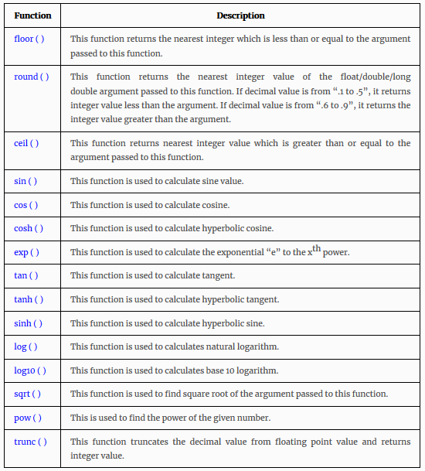

**Let’s go Competitive part**

1. A frog is currently at point 0 on the x-axis. It jumps a units to the right. Your task is to calculate the position of the frog after k jumps.

**Input**  
Two integers a, k such that 1 ≤  a, k  ≤  103, the jump length and the number of jumps.

**Output**  
The current position of the frog.

**Example**

Input  
5 3

Output  
15

1. A modified version of the above problem is that the frog jumps to the left. Starting at point 0 on the x-axis, it jumps b units to the left. Your task is to calculate the position of the frog after k jumps.

**Input**  
Two integers b, k such that 1 ≤  b, k  ≤  109, the jump length and the number of jumps.

**Output**  
The current position of the frog.

**Example**

Input  
5 4

Output  
-20

1. Given two numbers a and b, determine if a is divisible by b.

**Input**  
Two integers a and b such that 1 ≤ a, b ≤ 100.

**Output**  
Print "YES" if a is divisible by b. "NO" otherwise.

**Example**

Input  
6 3

Output  
YES

1. You have a rectangular plate and you want to add some gilding to it along the bordering cells so that it forms a golden ring. The plate is a rectangle that we split into w x h cells. Your task is to compute the number of cells gilded.

**Input**  
Two integers w, h such that 1 ≤  w, h  ≤  1000, the number of rows and columns.

**Output**  
Print the number of cells gilded.

**Example**

Input  
3 3

Output  
8

Input  
7 9

Output  
28

**Note**  
The examples are described below.

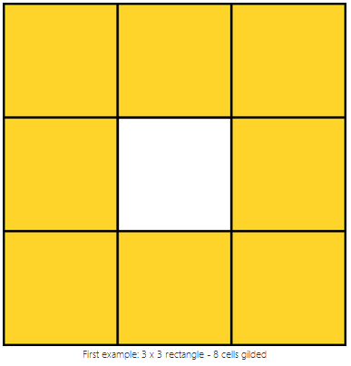

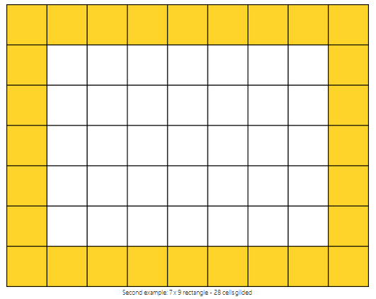

1. On one hot summer day Bob and his sister Alice decided to buy a watermelon. They chose the biggest and the ripest one, in their opinion. After that the watermelon was weighed, and the scales showed *w* kilos. They rushed home, dying of thirst, and decided to divide the melon, however they faced a hard problem. Bob and Alice are great fans of even numbers, so they want to divide the watermelon in such a way that each of the two parts weighs even number of kilos, at the same time it is not necessary that the parts are equal. They are extremely tired and want to start their meal as soon as possible, so you please help them and find out, if they can divide the watermelon in the way they want. For sure, each of them should get a part of positive weight.

**Input**

Integer number *w,* the weight of the watermelon bought by Alice and Bob.

**Output**

Print YES, if they can divide the watermelon into two parts, each of them weighing even number of kilos; and NO in the opposite case.

**Examples**

Input

8

Output

YES

**Note**

For example, they can divide the watermelon into two parts of 2 and 6 kilos respectively (another variant — two parts of 4 and 4 kilos).

An important factor of good programming is to identify the corner cases. Your logic may be to check whether the input is odd or even. But, don’t forget about the corner case 2 here (2 can’t be split into 2 equal even partitions)